MACHINE LEARNING BASED BUYER
SEGMENTATION AND
INVESTMENT PROFILING FOR REAL ESTATE MARKET INTELLIGENCE
Research Paper
Prepared from the completed real-estate buyer analytics project
Student: Iram
Domain: Financial Analyst
Project Context: Unified Mentor



Abstract
The real estate market consists of buyers with diverse demographic characteristics, purchasing objectives, geographic backgrounds, and financing preferences. Treating these buyers as a single group can result in generic marketing strategies and limited understanding of investment-oriented behavior. This study develops a machine learning-based buyer segmentation and investment profiling framework to identify meaningful patterns within real estate customer data and support data-driven decision-making.
The analysis uses a client dataset of 2,000 buyer records along with a complementary property dataset containing 10,000 records. The analytical workflow includes data cleaning, exploratory data analysis, categorical feature encoding, feature scaling, cluster evaluation, and customer profiling. K-Means clustering was applied to segment buyers, while the Elbow Method and Silhouette Score were used to evaluate potential cluster solutions. Although the highest reported silhouette score was obtained for K = 2, the final K = 4 solution was selected because it provided more useful and interpretable business segmentation.
The final clusters contained 15, 940, 942, and 103 customers, respectively. Among these segments, Cluster 3 demonstrated the highest investment proportion (34.95%) and the highest loan-use rate (41.75%), indicating comparatively stronger investment and financing orientation. Overall, 615 buyers were classified as investment-purpose buyers, while 1,385 were home-purpose buyers. The findings demonstrate that machine learning can transform heterogeneous real estate customer information into structured buyer segments that can support targeted marketing, financing assistance, investment-focused strategies, and customer intelligence. The resulting insights were also implemented through an interactive Stream lit dashboard, providing a practical decision-support layer for real estate market analysis.

Key words: Real Estate Market Intelligence; Buyer Segmentation; Machine Learning; K-Means Clustering; Investment Profiling; Buyer Behavior; Real Estate Analytics.

Introduction
The real estate industry generates a large amount of customer and property-related information, including demographic characteristics, geographic location, acquisition purpose, financing behavior, satisfaction levels, property prices, unit categories, and listing status. However, the availability of such data does not automatically provide a clear understanding of the different types of buyers present in the market. Buyers may have different reasons for acquiring property, different financing requirements, and different behavioral characteristics. Therefore, identifying meaningful buyer groups is important for developing more focused marketing strategies and improving real estate decision-making.
Traditional customer segmentation generally relies on predefined categories or simple demographic characteristics. Such approaches may not fully capture the underlying relationships within customer data. Machine learning, particularly unsupervised learning techniques, provides an alternative approach by identifying groups of customers based on similarities across multiple characteristics. In this project, machine learning is used to segment real estate buyers and develop investment profiles that can provide a more structured understanding of customer behavior.
The present study uses a client dataset containing 2,000 records and a property dataset containing 10,000 records. The client data includes variables such as client type, gender, country, region, age, acquisition purpose, loan application, referral channel, and satisfaction score. The property dataset provides additional market context through variables such as listing status, unit category, sale price, floor area, and related property characteristics. Exploratory Data Analysis (EDA) was first conducted to understand the distribution and relationships within both datasets before applying machine learning techniques.
For buyer segmentation, the project applies K-Means clustering, supported by Hierarchical Clustering as a comparative approach. Feature encoding and scaling were performed to prepare the data for distance-based clustering. The Elbow Method and Silhouette Score were used to assess different numbers of clusters. Although the highest silhouette score among the tested values was obtained at K = 2, the final project adopted four clusters to obtain a more meaningful and interpretable business segmentation.
The resulting four buyer clusters contain 15, 940, 942, and 103 customers, respectively. The clusters were further examined according to investment purpose and loan behavior to develop investment-oriented buyer profiles. The analysis found that Cluster 3 had the highest investment proportion (34.95%) and the highest loan-use rate (41.75%), making it particularly relevant from an investment and financing perspective. The project also translates these analytical findings into an interactive Stream lit dashboard, allowing users to explore buyer segments through demographic, geographic, investment, and financing characteristics.
Overall, this study demonstrates how machine learning and data analytics can be applied to real estate customer data to move beyond basic descriptive analysis and develop data-driven buyer segmentation and investment intelligence. The findings can help real estate businesses understand their customer base more effectively and support more targeted marketing, financing communication, and investment-related decision-making.

Dataset Description
This study uses two datasets, clients.csv and properties.csv, to analyze buyer behavior and develop a machine-learning-based segmentation framework for real estate market intelligence. The client dataset is the primary dataset used for buyer segmentation, while the property dataset provides additional information about the real estate market and property characteristics. The notebook confirms that the client dataset initially contains 2,000 records and 12 variables, whereas the property dataset contains 10,000 records and 9 variables.
3.1 Client Dataset
The client dataset contains information about 2,000 real estate buyers. It captures demographic, geographic, behavioral and financing-related characteristics of the buyers. The variables include ClientID, client type, first name, last name, date of birth, gender, country, region, acquisition purpose, satisfaction score, loan applied, and referral channel. The project requirements describe ClientID as the unique identifier, while client type distinguishes individual and corporate buyers. Other variables provide information about the buyer's location, purchasing purpose, financing behavior, customer satisfaction and acquisition source.
During data preparation, the date of birth field was converted into a proper datetime format and subsequently used to derive age, which was included as an important analytical characteristic. The dataset was also checked for missing values and duplicate records. The notebook reports zero duplicate client rows.
The dataset provides a useful basis for understanding buyer characteristics. The analysis found 1,012 male and 988 female buyers, while the acquisition-purpose analysis identified 1,385 home-purpose buyers and 615 investment-purpose buyers. The average buyer age was 54.60 years, with ages ranging from 24 to 94 years. These characteristics were subsequently used to understand differences between buyer groups and support the clustering analysis.
3.2 Property Dataset
The second dataset, properties.csv, contains 10,000 property records with 9 variables. It provides information related to property listings and transactions, including listing, tower number, transaction date, unit category, unit number, floor area sqft, sale price, listing status, and client ref.
The property dataset was also subjected to data cleaning. The transaction date variable was converted into datetime format, while sale price, originally stored as text containing currency symbols and commas, was converted into a numerical format for analysis. The notebook also confirms that there were no duplicate property records.
Exploratory analysis showed that 7,305 properties were sold and 2,695 were available. In terms of property type, 8,547 properties were apartments and 1,453 were offices. The dataset also contains information on tower number, floor area and sale price, allowing the project to examine broader property-market patterns alongside buyer behavior.
3.3 Role of the Datasets in the Study
The two datasets serve complementary purposes. The client dataset forms the core of the machine-learning segmentation analysis, as its variables directly describe buyer characteristics and behavior. The property dataset provides market context by describing property availability, transaction status, property category, floor area and sale prices. Together, they support a broader understanding of the relationship between buyer characteristics and the real estate market.
The cleaned client data was subsequently transformed through feature engineering, categorical encoding and scaling before applying clustering techniques. The final analysis used K-Means clustering to identify four practically meaningful buyer segments.

Methodology
This study follows a structured machine-learning methodology to identify meaningful buyer segments and understand investment and financing behaviour in the real estate market. The overall process consists of data preparation, exploratory data analysis, feature engineering, categorical encoding, feature scaling, clustering, cluster evaluation, and interpretation of buyer segments. The methodology was implemented using Python and its data-science libraries in Google Colab.
4.1 Data Preparation and Cleaning
The study uses two datasets, namely the client dataset containing 2,000 buyer records and the property dataset containing 10,000 property records. The client dataset was the primary dataset for buyer segmentation, while the property dataset was used to understand broader property-market characteristics.
The first stage involved inspecting the structure, data types, missing values and duplicate records in both datasets. The date of birth variable in the client dataset was converted into a date format and used to derive the age variable. Similarly, the transaction date variable in the property dataset was converted into an appropriate date format. The sale price field was cleaned and converted into a numerical format so that it could be used for quantitative analysis. Duplicate records were also checked during preprocessing.
Categorical values were reviewed and normalized where necessary to maintain consistency across the dataset. Missing client attributes were also considered during the cleaning process.
4.2 Exploratory Data Analysis
After data cleaning, Exploratory Data Analysis (EDA) was conducted to understand the characteristics and distribution of buyers and properties before applying machine learning.
For the client dataset, the analysis examined variables such as client type, gender, country, region, age, acquisition purpose, satisfaction score, loan application and referral channel. The analysis helped identify the overall composition of buyers and provided an initial understanding of investment and financing behavior.
For the property dataset, EDA focused on listing status, unit category, tower information, floor area and sale price. These analyses provided additional market context and helped understand the characteristics of the available property records.
4.3 Feature Engineering
Feature engineering was performed to transform the available raw information into variables suitable for analysis. One of the main transformations was the creation of age from date of birth. This provided a more directly interpretable demographic feature for buyer segmentation.
The analytical features were selected based on their relevance to buyer characteristics and behavior. Variables related to demographic profile, geographic location, acquisition purpose, financing behavior and satisfaction were considered in developing the segmentation framework.
4.4 Feature Encoding
Since clustering algorithms require numerical input, categorical variables were converted into numerical representations. The project methodology considered encoding for variables such as client type, region, acquisition purpose, referral channel and country. Depending on the nature of the variable, categorical encoding techniques such as one-hot encoding and label encoding were used.
This transformation allowed categorical buyer characteristics to be incorporated into the machine-learning process without using the original text labels directly.
4.5 Feature Scaling
Feature scaling was applied before clustering because K-Means is a distance-based algorithm. Variables such as age and satisfaction score can have different numerical ranges, and without scaling, variables with larger numerical values could have a disproportionate influence on the clustering process.
The project therefore used scaled features for the clustering stage so that the selected variables could contribute more comparably to distance calculations.
4.6 Clustering Approach
The study applies unsupervised machine learning, as there was no predefined target variable representing buyer segments. Two clustering approaches were considered: K-Means Clustering and Hierarchical Clustering.
K-Means was selected for the final implementation because it provides a relatively efficient and interpretable approach for dividing buyers into groups based on similarities in their characteristics. Hierarchical clustering was considered as an alternative approach because it can reveal nested relationships between observations.
The final K-Means implementation used:
- Number of clusters (K) = 4
- Random state = 42
- n_init = 10
The resulting cluster labels were then added to the client dataset and used for subsequent buyer profiling and behavioral analysis.
4.7 Determining the Number of Clusters
To examine an appropriate number of clusters, the study evaluated different values of K from 2 to 10. Two evaluation techniques were used: the Elbow Method and the Silhouette Score.
The Elbow Method examined the reduction in within-cluster variation as the number of clusters increased. The Silhouette Score was then used to assess how well observations were separated within their assigned clusters.

The silhouette scores obtained were:
Number of Clusters (K) | Silhouette Score
2 | 0.2187
3 | 0.0881
4 | 0.0583
5 | 0.0821
6 | 0.0439
7 | 0.0692
8 | -0.0296
9 | 0.0902
10 | 0.0945

The highest Silhouette Score was obtained at K = 2 (0.2187). However, the final project selected K = 4 because the purpose of the study was not only statistical separation but also to obtain a more useful and interpretable segmentation for real estate business analysis. Therefore, K=4 was retained as the final business-oriented clustering solution.
4.8 Cluster Profiling and Interpretation
After generating the four clusters, each segment was profiled using demographic and behavioral characteristics. The analysis compared clusters according to average age, satisfaction score, acquisition purpose, loan application, client type, gender and geographic distribution.
Investment behavior was particularly important because the project focuses on investment profiling. The proportion of investment buyers within each cluster was therefore calculated. Similarly, loan application behavior was analyzed to identify segments with relatively greater financing requirements.
The final clusters contained 15, 940, 942 and 103 buyers, respectively. These profiles were subsequently used to identify differences between buyer groups and develop business-oriented insights.
4.9 Business Intelligence and Dashboard Development
The final stage involved translating the analytical results into an interactive Stream lit dashboard. The dashboard provides different views of buyer segmentation, investment behavior, geographic patterns and segment-level insights.
The dashboard includes modules for Buyer Segmentation Overview, Investor Behavior Dashboard, Geographic Buyer Analysis, and Segment Insights Panel. Users can explore the results using filters such as country, region, acquisition purpose and client type.
Overall, this methodology combines data analysis and unsupervised machine learning with practical business interpretation, allowing the project to move from raw buyer data to actionable buyer segments and investment-oriented real estate insights.
Exploratory Data Analysis
Exploratory Data Analysis (EDA) was conducted to obtain an initial understanding of the buyer and property datasets before applying machine learning techniques. The purpose of EDA was to identify important patterns in buyer demographics, purchasing objectives, financing behavior, satisfaction levels, geographic distribution, and property characteristics. The analysis also helped determine which variables were relevant for the subsequent buyer segmentation process.
4.1 EDA of Client Dataset
The client dataset consists of 2,000 buyer records. The analysis examined the major categorical and numerical variables available in the dataset, including client type, gender, acquisition purpose, loan application, referral channel, satisfaction score, country, region and age.
Client Type
The analysis first examined the distribution of buyers according to their client type. The dataset distinguishes between Individual and Company clients. This analysis was useful for understanding whether the buyer population was primarily composed of individual customers or corporate entities and was later considered during cluster profiling.
Gender Distribution
Gender was analyzed to understand the demographic composition of the buyer population. The dataset contains 1,012 male buyers and 988 female buyers, showing a relatively balanced gender distribution. This variable was subsequently considered when comparing the characteristics of the identified buyer segments.
Acquisition Purpose
Acquisition purpose was one of the most important variables for this study because the project specifically focuses on investment profiling. The analysis identified 1,385 Home buyers and 615 Investment buyers among the 2,000 clients. Thus, approximately 30.75% of the buyers were classified as investment-oriented, while the remaining buyers were purchasing primarily for home purposes.
This analysis provided an important foundation for later comparing investment behavior across machine-learning-generated clusters.
Loan Application Behavior
Loan application behavior was examined to understand the financing requirements of buyers. The analysis classified clients according to whether they had applied for a loan. This variable was particularly relevant because financing preferences can help distinguish buyer groups and provide useful information for real estate businesses when designing financing-related offers.
Referral Channel
The referral channel was analyzed to understand how buyers were acquired. The project considered Agency, Client and Website as referral sources. The distribution of these channels was later compared across clusters to determine whether different buyer segments showed different acquisition patterns. The cluster-level analysis indicates that the Website was an important referral source across the identified segments.
Satisfaction Score
Customer satisfaction was also examined as part of the EDA. The dataset contains satisfaction scores on a numerical scale, allowing the study to understand the general level of buyer satisfaction and subsequently compare satisfaction across different segments.
The average satisfaction levels observed in the final clusters were close to each other, ranging from 3.02 to 3.27, indicating that satisfaction did not vary dramatically between the major groups.
Age Distribution
Age was derived from the buyers' date of birth during the feature-engineering stage. The resulting age variable was then explored statistically. The dataset contains buyers between 24 and 94 years, with an average age of 54.60 years. The median age was 55 years, while the first and third quartiles were 40 and 69 years, respectively.
Age was subsequently included as a numerical feature in the machine-learning analysis because it provides an important demographic dimension for buyer profiling.
Geographic Distribution
Geographic EDA was performed using the country and region variables. The analysis found that buyers were distributed across several countries, with the USA accounting for 1,538 buyers, followed by the UK with 95 and Canada with 85. Germany, France, Belgium, Mexico, Australia, Russia and Denmark represented smaller portions of the dataset.
This geographic analysis was important because real estate demand and investment behavior can differ across locations. Geographic characteristics were therefore also included in the clustering and subsequent segment profiling.

4.2 EDA of Property Dataset
EDA was also performed on the 10,000-record property dataset to provide broader market context for the buyer analysis. The analysis examined property listing status, unit category, floor area and sale price.
Property Listing Status
The analysis showed that 7,305 properties were sold, while 2,695 properties were available. This indicates that the dataset contains a substantially larger number of completed/sold listings than currently available properties.
Unit Category
The property dataset contains two major unit categories: Apartments and Offices. Apartments represented 8,547 records, whereas offices accounted for 1,453 records. This shows that the property dataset is strongly dominated by residential apartment listings.
Floor Area and Sale Price
The relationship between floor area and sale price was also examined to understand whether larger properties were associated with higher transaction values. Average sale prices were additionally compared across unit categories. These analyses provided a basic understanding of property pricing patterns and helped complement the buyer-focused analysis.

4.3 EDA Findings and Relevance to Machine Learning
Overall, the EDA established several important characteristics of the dataset. The buyer population consists of 2,000 clients with diverse demographic, geographic and behavioral characteristics, including differences in age, gender, acquisition purpose, financing behavior and referral source. The property dataset adds market-level information through 10,000 property records, including their status, category, size and sale price.
The EDA was therefore an important intermediate stage between data cleaning and machine learning. It helped identify the variables suitable for buyer segmentation and provided the baseline against which the resulting clusters could later be interpreted. The subsequent clustering analysis used relevant buyer characteristics including client type, gender, country, region, acquisition purpose, loan application, referral channel, age and satisfaction score.

K-Means Clustering, Elbow Method and Silhouette Analysis
After completing data cleaning, feature engineering, encoding, and scaling, K-Means clustering was applied to segment real estate buyers into groups with similar characteristics. Since the dataset did not contain predefined buyer-segment labels, an unsupervised learning approach was considered appropriate. The objective was to identify groups of buyers that share similar demographic, behavioural, purchasing, and financing characteristics.
K-Means Clustering
K-Means is an unsupervised machine learning algorithm that divides observations into a predefined number of clusters. Each observation is assigned to the cluster whose centroid is closest to it based on distance. The centroids are then repeatedly updated until the clustering solution becomes stable.
In this study, different values of K, ranging from 2 to 10, were examined to determine a suitable number of buyer segments. The clustering process was performed using the scaled feature set so that variables with larger numerical ranges would not dominate the distance calculations.
The final model was implemented using K = 4, with random_state = 42 and n_init = 10. The four resulting clusters contained 15, 940, 942, and 103 buyers, respectively. These clusters were subsequently profiled using variables such as age, satisfaction score, acquisition purpose, loan application, gender, client type, and geographic characteristics.
Elbow Method
The Elbow Method was used as one of the approaches for determining the appropriate number of clusters. It evaluates the Within-Cluster Sum of Squares (WCSS), also referred to as inertia, for different values of K.
As the number of clusters increases, WCSS generally decreases because observations are assigned to more groups. However, after a certain point, the improvement becomes relatively small. This point is commonly referred to as the elbow, and it provides an indication of a potentially suitable cluster count.
In this project, the Elbow Method was evaluated for values of K from 2 to 10. The resulting curve was considered together with the Silhouette analysis and the practical usefulness of the resulting buyer groups rather than relying on the elbow alone.
Silhouette Analysis
The Silhouette Score was used to evaluate the quality of the clustering structure. It measures how similar an observation is to the observations within its own cluster compared with observations belonging to other clusters. A higher score generally indicates better separation between clusters.

The following scores were obtained during the analysis:

Number of Clusters (K) | Silhouette Score
2 | 0.2187
3 | 0.0881
4 | 0.0583
5 | 0.0821
6 | 0.0439
7 | 0.0692
8 | -0.0296
9 | 0.0902
10 | 0.0945

The highest Silhouette Score was obtained for K = 2, with a score of 0.2187. However, the study did not select the final number of clusters solely on the basis of this score. K = 4 was selected as the final solution because it provided more detailed and practically interpretable buyer segments for the project's real estate market-intelligence objective.
This distinction is important: K = 2 performed best according to the Silhouette Score, whereas K = 4 was chosen as the final business-oriented segmentation solution. The four-cluster solution allowed the study to examine differences in investment and loan behavior in greater detail.

Cluster | Number of Buyers
Cluster 0 | 15
Cluster 1 | 940
Cluster 2 | 942
Cluster 3 | 103
Total | 2,000

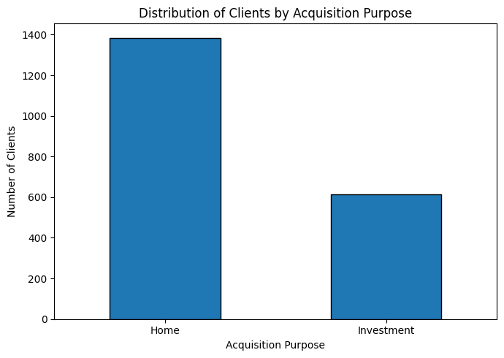

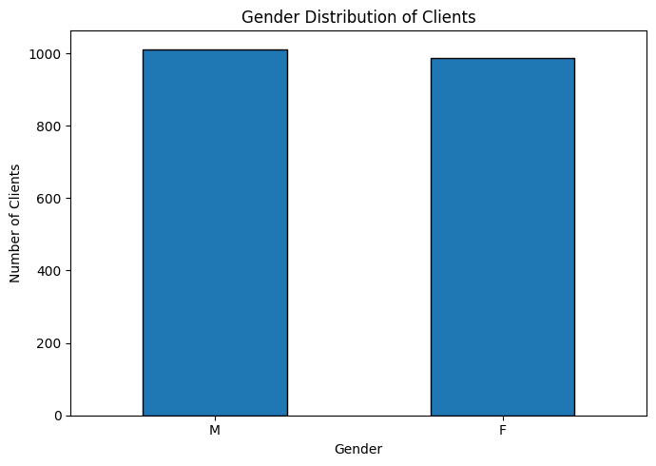

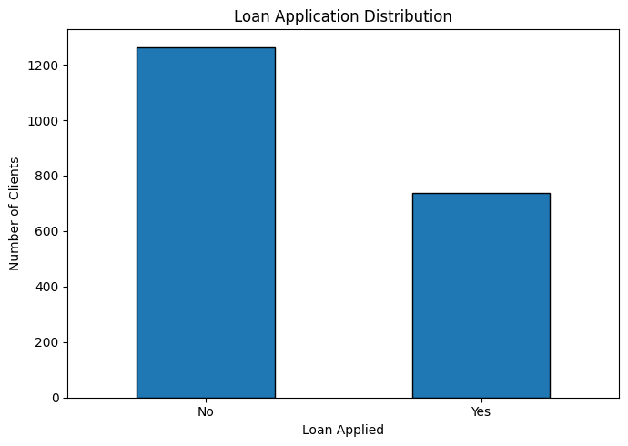

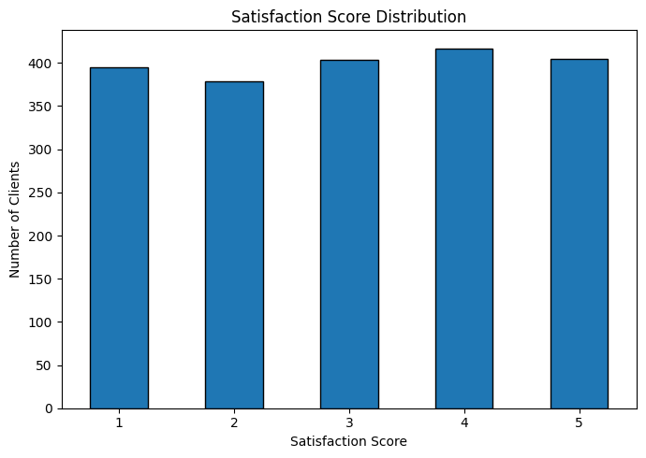
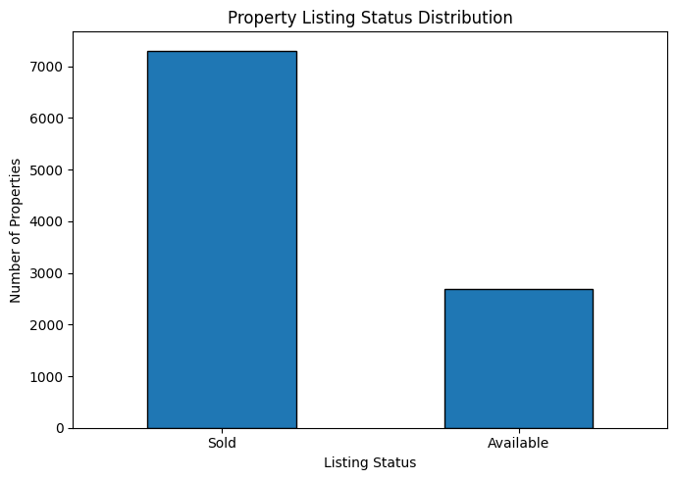
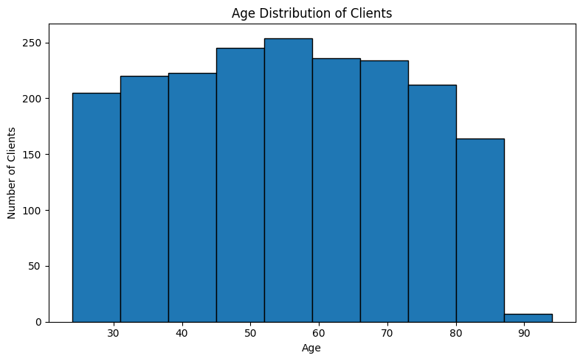
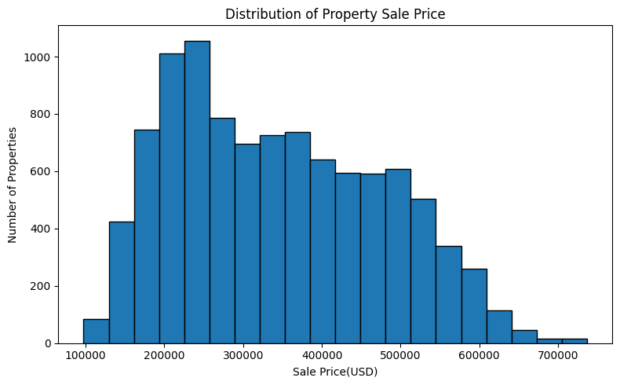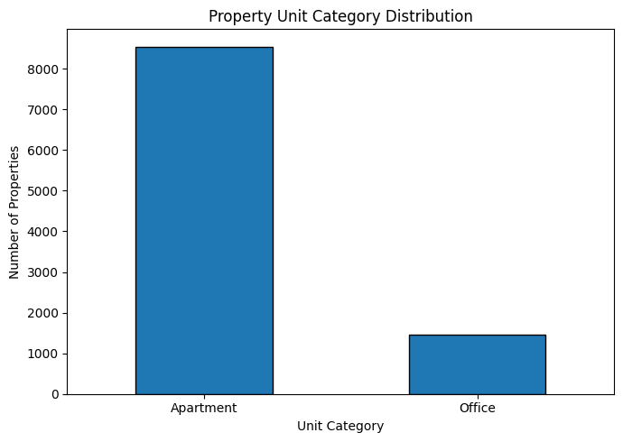

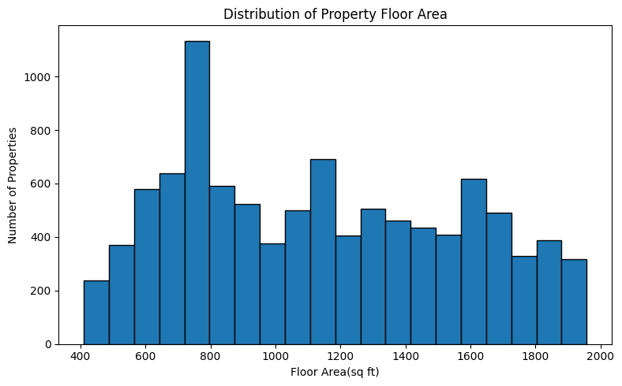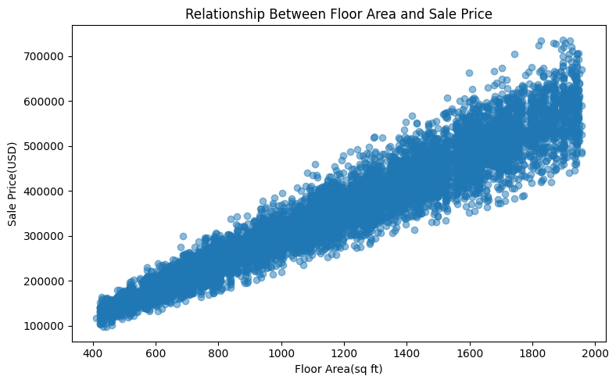

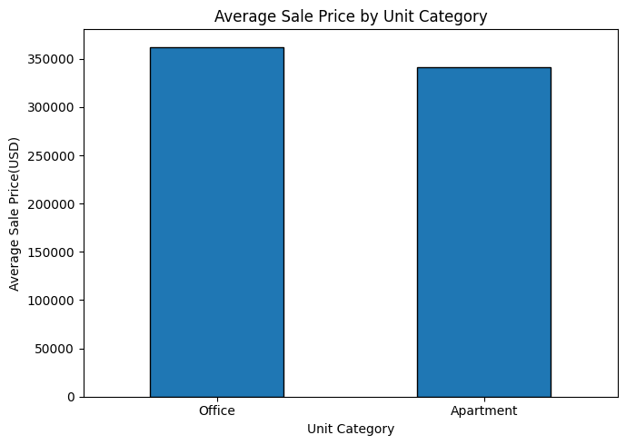

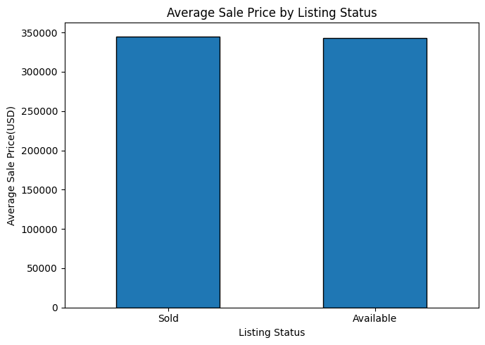
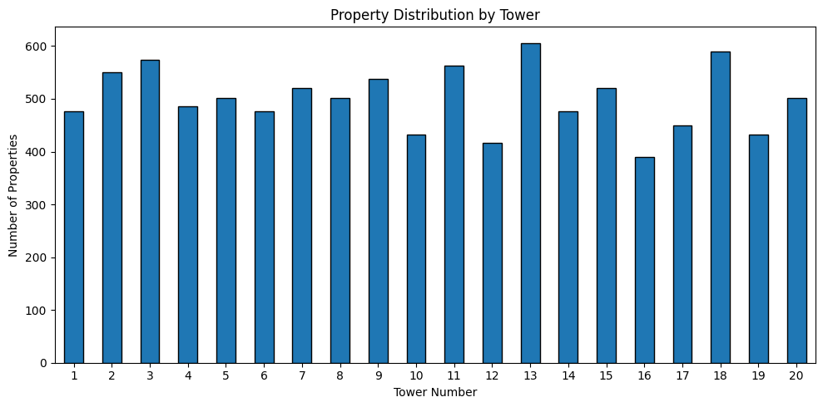

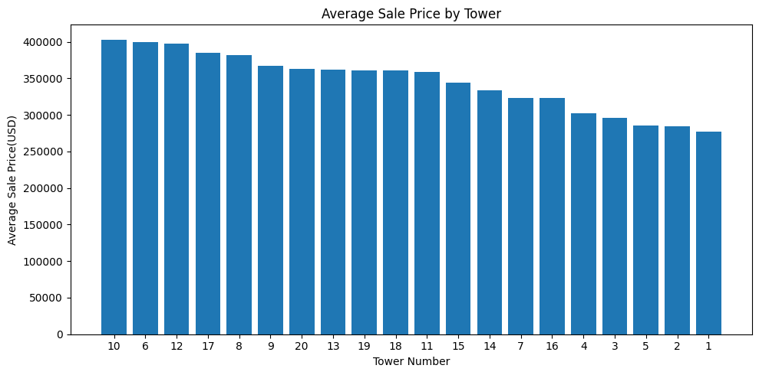
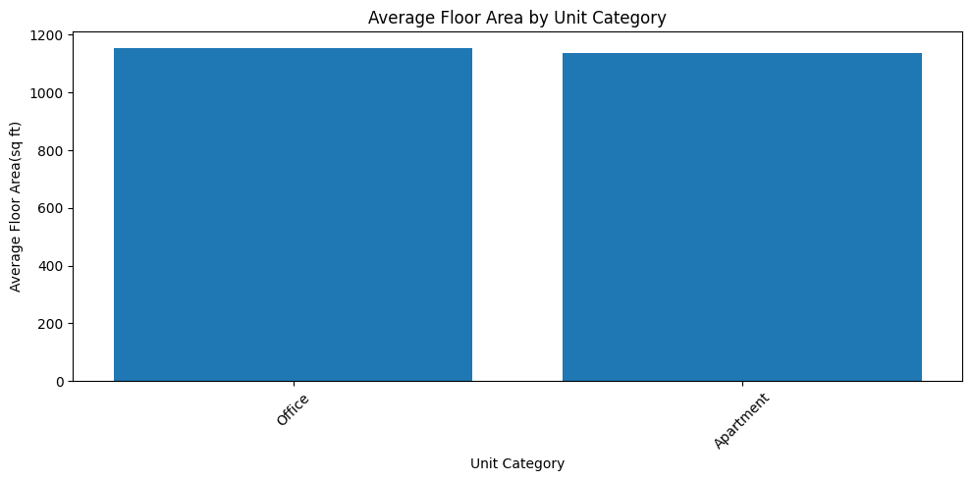

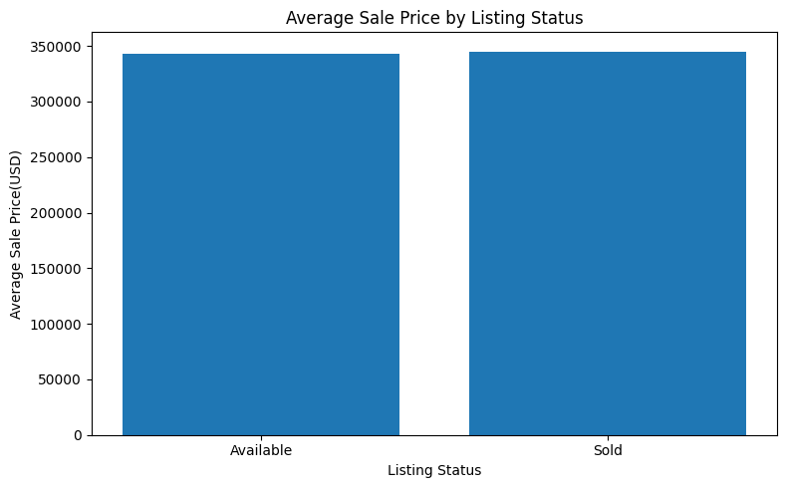
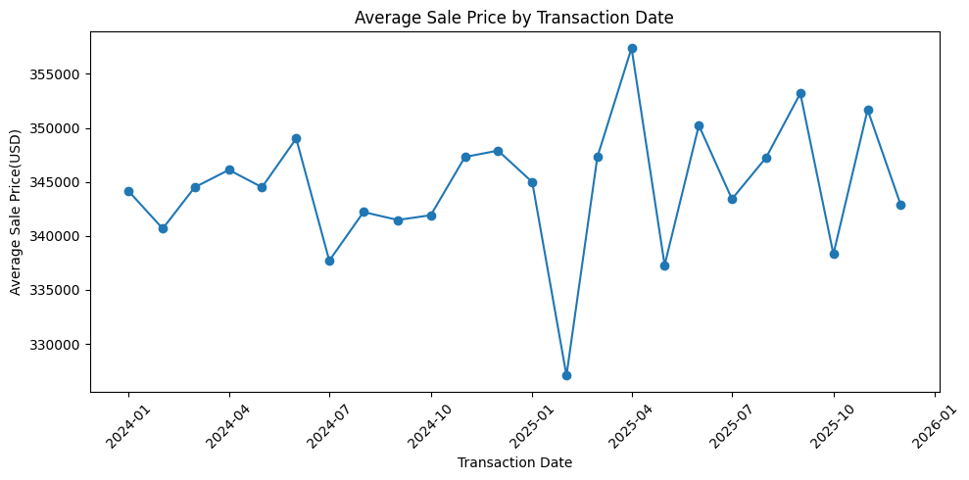

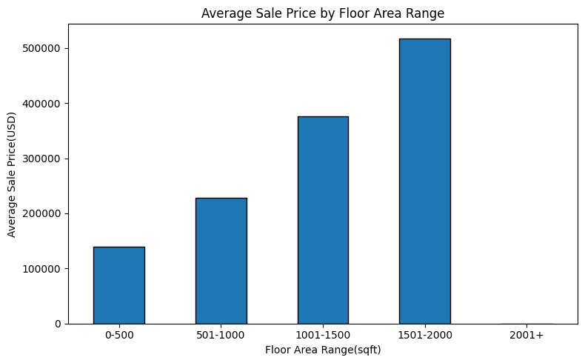
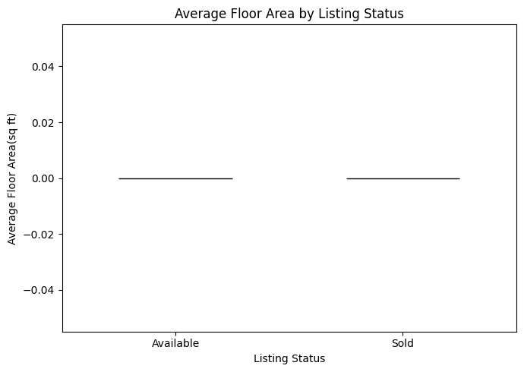

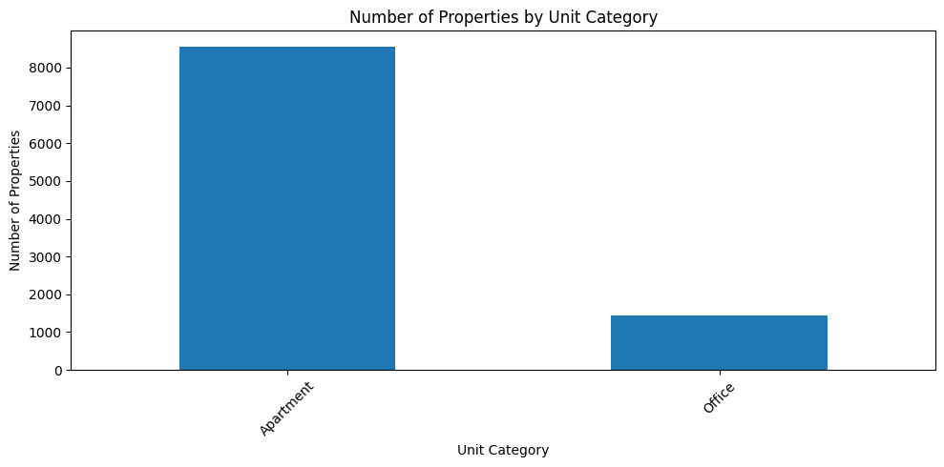
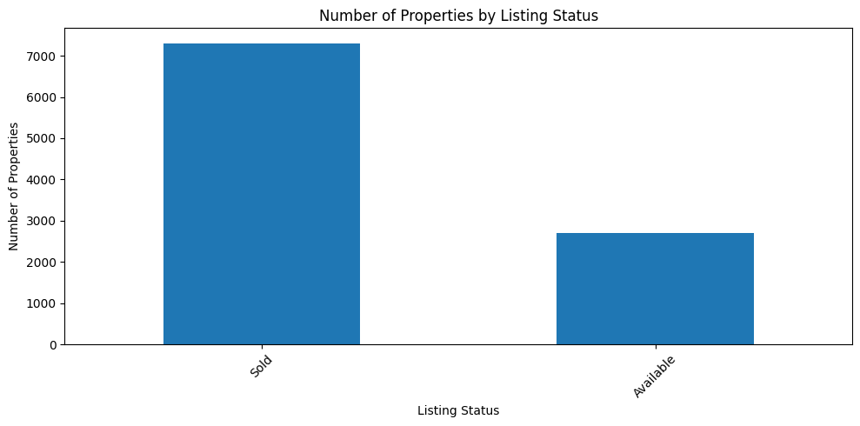

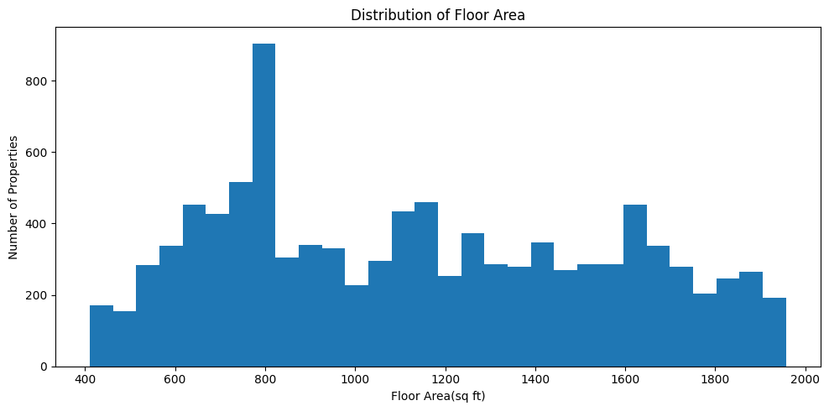
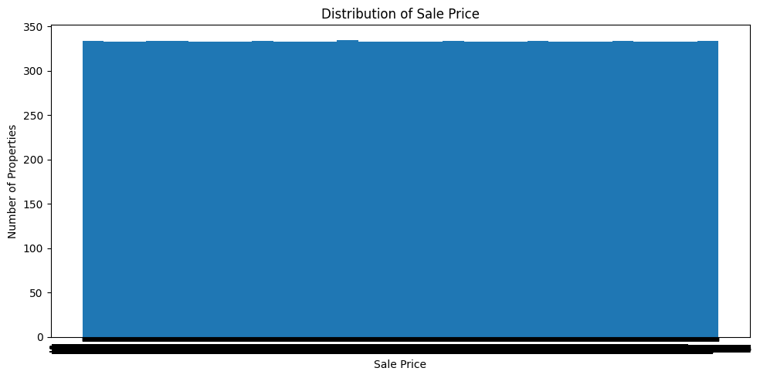

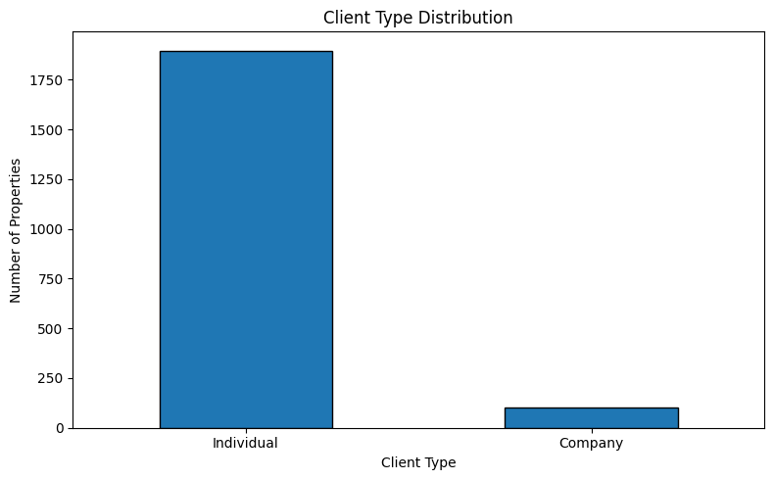

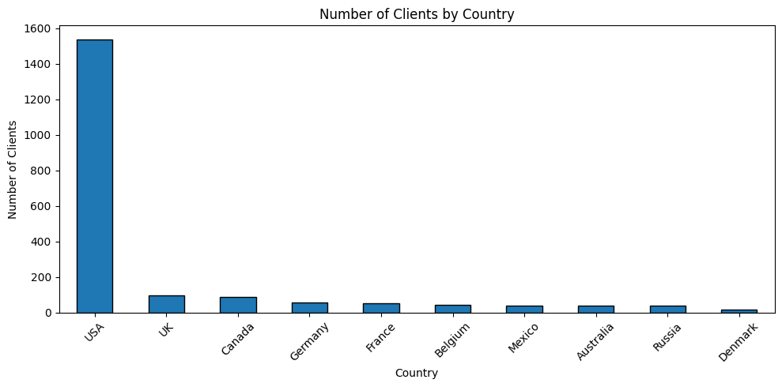

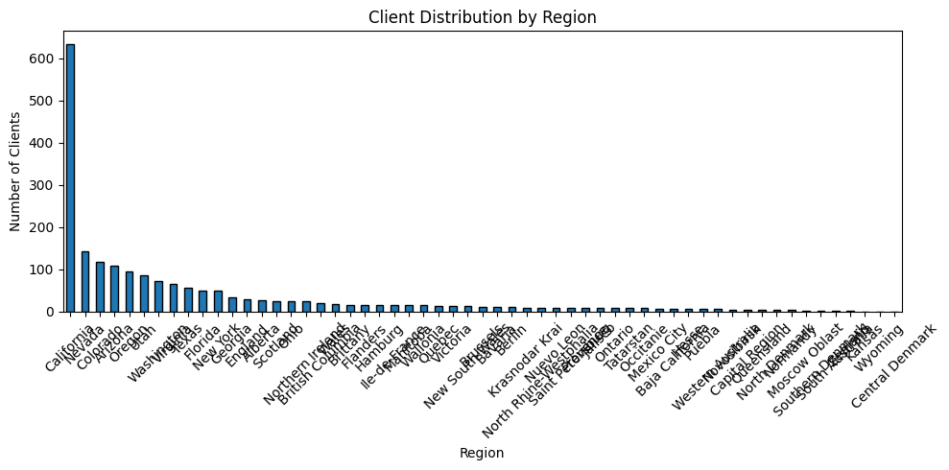

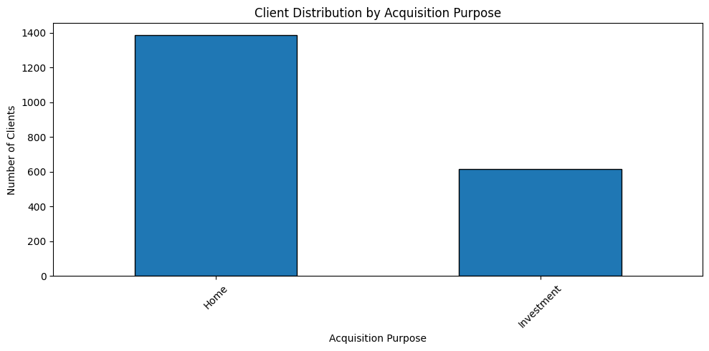

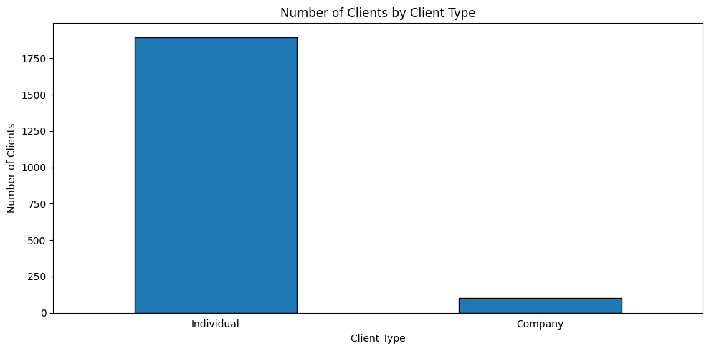


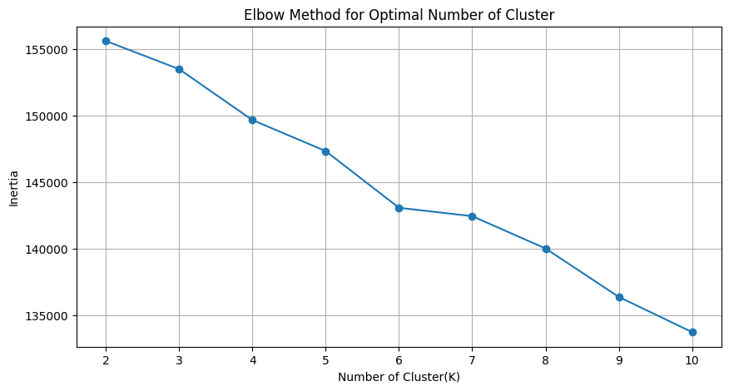
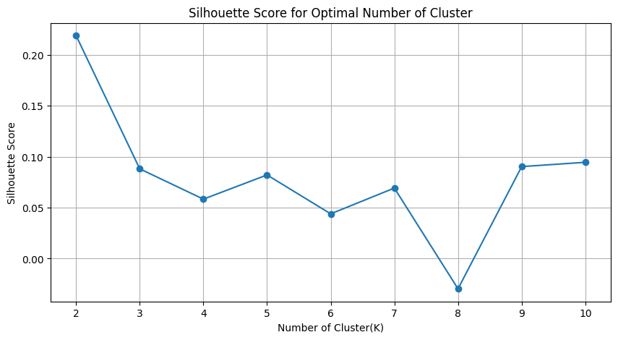

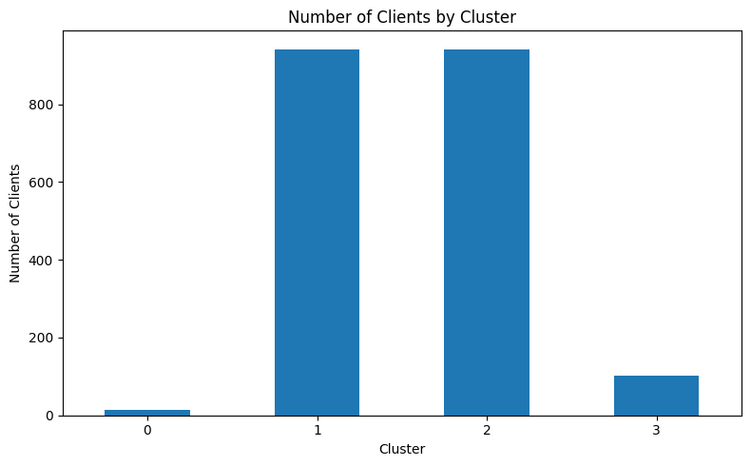

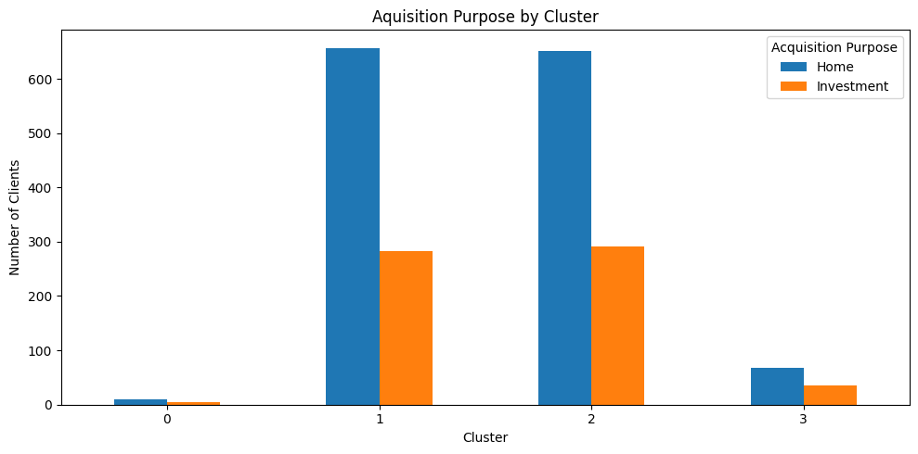

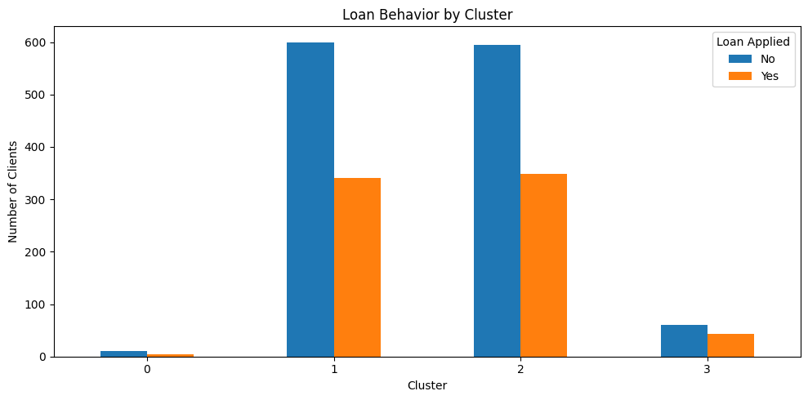
Four-Cluster Analysis
The final K-Means model divided the 2,000 real estate buyers into four clusters based on similarities in their demographic, behavioral and financing-related characteristics. The four clusters contained 15, 940, 942 and 103 buyers, respectively. Clusters 1 and 2 were the dominant segments, together accounting for 1,882 buyers, while Clusters 0 and 3 were comparatively smaller groups.

Table: Final Four-Cluster Profile:

Cluster | Buyers | Avg. Age | Avg. Satisfaction | Investment Buyers | Investment % | Loan Users | Loan %
Cluster 0 | 15 | 50.27 | 3.27 | 5 | 33.33% | 5 | 33.33%
Cluster 1 | 940 | 54.71 | 3.03 | 283 | 30.11% | 340 | 36.17%
Cluster 2 | 942 | 55.43 | 3.02 | 291 | 30.89% | 348 | 36.94%
Cluster 3 | 103 | 46.66 | 3.07 | 36 | 34.95% | 43 | 41.75%
Cluster 0
Cluster 0 is the smallest segment, containing only 15 buyers. The average age of buyers in this group is 50.27 years, with the highest average satisfaction score among the four clusters at 3.27. Five buyers are classified as investment buyers, representing 33.33% of the cluster, while five buyers have applied for loans.
The geographic analysis identifies Canada as the dominant country and Manitoba as the dominant region for this cluster. All buyers in this cluster are individual clients. Because of its very small size, the characteristics of this cluster should be interpreted cautiously.
Cluster 1
Cluster 1 contains 940 buyers, making it one of the two major segments. The average age is 54.71 years, and the average satisfaction score is 3.03. The cluster contains 283 investment buyers, equivalent to 30.11%, while 340 buyers (36.17%) have applied for loans.
The cluster is composed of individual clients and is strongly concentrated in the USA, with California identified as its dominant region. The cluster also shows a strong presence of female buyers in the reported cross-tabulation.
Cluster 2
Cluster 2 is the largest segment, containing 942 buyers. Buyers in this group have an average age of 55.43 years, which is the highest average age among the four clusters. The average satisfaction score is 3.02.
This cluster contains 291 investment buyers, representing 30.89% of the segment. A total of 348 buyers (36.94%) have applied for loans. Similar to Cluster 1, the group is predominantly concentrated in the USA, with California being the dominant region. The reported demographic profile identifies this cluster as consisting of individual clients and predominantly male buyers.
Cluster 3
Cluster 3 contains 103 buyers and has the lowest average age, at 46.66 years. It contains 36 investment buyers, giving it the highest investment proportion of 34.95% among all four clusters.
The cluster also contains 43 loan users, corresponding to a 41.75% loan-use rate, which is the highest among the four segments. The cluster is company-dominated, unlike Clusters 0, 1 and 2, which are reported as individual-client groups. The dominant country is the USA, with California as the dominant region.
Comparative Interpretation
The four-cluster analysis reveals several important differences in buyer behaviour. Clusters 1 and 2 represent the core buyer population, accounting for 1,882 of the 2,000 buyers. Their investment proportions are relatively similar, at approximately 30%, while their loan-use rates are approximately 36–37%.
Cluster 3 is particularly important from an investment and financing perspective. Although it is much smaller than Clusters 1 and 2, it has both the highest investment share (34.95%) and the highest loan-use rate (41.75%). This makes it a potentially important segment for specialized investment and financing-related engagement.
Cluster 0 records the highest satisfaction score (3.27), but its very small sample size of only 15 buyers means that this finding should not be generalized to the wider buyer population. Overall, the four-cluster solution provides a more detailed basis for understanding differences in buyer behavior and supports the project's objective of developing practical real estate buyer and investment intelligence.

Investment and Loan Behavior Analysis
Investment purpose and loan application behavior were analyzed to understand the financial preferences of different buyer segments. These two variables are particularly important for real estate market intelligence because they provide an indication of whether buyers are purchasing property primarily for personal use or investment and whether they require external financing.
Investment behavior
The overall dataset contains 615 investment-oriented buyers out of 2,000 buyers, indicating that investment buyers account for 30.75% of the total buyer population. The remaining 1,385 buyers have home acquisition as their primary purpose.

The cluster-level analysis shows that investment behavior varies across the four buyer segments:

Cluster | Total Buyers | Investment Buyers | Investment Share
Cluster 0 | 15 | 5 | 33.33%
Cluster 1 | 940 | 283 | 30.11%
Cluster 2 | 942 | 291 | 30.89%
Cluster 3 | 103 | 36 | 34.95%

Cluster 3 has the highest proportion of investment buyers (34.95%), followed by Cluster 0 at 33.33%. Clusters 1 and 2 have relatively similar investment shares of 30.11% and 30.89%, respectively.
Although Cluster 3 is considerably smaller than Clusters 1 and 2, its higher investment proportion makes it an important segment for identifying buyers with stronger investment-oriented behavior.

Loan behavior
Loan application behavior was analyzed alongside acquisition purpose to understand the financing requirements of the buyer segments. Overall, 736 buyers applied for a loan, while the remaining 1,264 buyers did not apply for a loan.

Cluster | Total Buyers | Loan Users | Loan Usage Rate
Cluster 0 | 15 | 5 | 33.33%
Cluster 1 | 940 | 340 | 36.17%
Cluster 2 | 942 | 348 | 36.94%
Cluster 3 | 103 | 43 | 41.75%

Cluster 3 records the highest loan application rate at 41.75%, indicating comparatively greater reliance on financing within this segment. Cluster 2 follows with 36.94%, while Cluster 1 records 36.17%. Cluster 0 has the lowest loan-use rate at 33.33%, although its small sample size limits the strength of comparison.
Relationship Between Investment and Loan behavior
The combined analysis of investment and loan behavior provides a more meaningful understanding of the buyer segments. Cluster 3 stands out because it has both the highest investment share (34.95%) and the highest loan application rate (41.75%). This suggests that buyers in this segment may represent an important target group for investment-oriented properties and financing-related services.
Clusters 1 and 2, which together contain the majority of buyers, show relatively similar patterns in both investment and loan behavior. Their investment shares are close to 30%, while approximately 36–37% of buyers in each cluster have applied for loans.
Overall, the analysis demonstrates that investment preference and financing behavior differ across buyer segments. These differences can help real estate businesses develop more targeted marketing strategies, investment offerings and financing solutions. In particular, Cluster 3 can be considered a potentially valuable segment for investment-focused and loan-supported real estate offerings, while the larger Clusters 1 and 2 may require broader strategies due to their substantial buyer population.

Business Implications
The buyer segmentation analysis provides several practical implications for real estate businesses. By identifying differences in buyer characteristics, investment preferences, and financing behaviour, the results can support more targeted marketing, customer relationship management, and investment strategies.
1. Targeted Marketing Strategies
The four clusters demonstrate that buyers do not behave as a single homogeneous group. Real estate companies can therefore design segment-specific marketing campaigns instead of using the same approach for all customers. For example, communication can be tailored according to acquisition purpose, age, location, client type, and financing preferences.
2. Focus on Investment-Oriented Buyers
Investment buyers account for 615 out of 2,000 buyers (30.75%). This represents a significant customer group for developers, brokers, and investment-focused real estate firms. Investment-oriented buyers can be targeted with property portfolios, rental-income opportunities, capital-appreciation propositions, and other investment-related offerings.
3. Cluster 3 as a High-Potential Segment
Cluster 3 is particularly relevant from a business perspective because it has the highest investment proportion (34.95%) as well as the highest loan application rate (41.75%). Although the segment contains only 103 buyers, its characteristics suggest that it may be suitable for targeted investment properties combined with financing solutions.
4. Financing and Loan-Based Opportunities
The analysis identifies 736 loan applicants across the buyer population. This indicates a considerable requirement for financing among customers. Real estate businesses can use cluster-level loan behavior to work more effectively with banks and financial institutions and to develop targeted financing assistance, loan referrals, or mortgage-related services.
5. Geographic Targeting
The geographic analysis shows that buyer activity is concentrated in particular countries and regions, with the USA and California being particularly prominent in the major clusters. Businesses can use these geographic patterns to allocate marketing budgets, strengthen local partnerships, and focus sales activities in areas with a larger concentration of potential buyers.
6. Customer Relationship Management
The segmentation can also support more personalised customer relationship management. Instead of treating every buyer identically, companies can use cluster profiles to understand the likely needs and preferences of different customer groups. This can improve communication, follow-up strategies, property recommendations, and customer engagement.
7. Data-Driven Decision Making
The project demonstrates how machine learning can convert customer-level data into actionable market intelligence. The interactive Stream lit dashboard further enables users to explore clusters, investment behavior, loan behavior, and geographic patterns. This can help managers make decisions based on observed customer patterns rather than relying only on general market assumptions.
Overall Business Implication
Overall, the four-cluster segmentation provides a practical framework for differentiated marketing, investment targeting, financing support, and customer management. In particular, Cluster 3 represents an interesting opportunity because of its relatively high investment and loan-use rates, while Clusters 1 and 2 are strategically important because they represent the majority of the buyer population. Thus, the segmentation approach can help real estate businesses allocate resources more effectively and develop strategies according to the characteristics of different buyer groups.

Recommendations
Based on the findings from the buyer segmentation and investment and loan behavior analysis, the following recommendations can be made to improve real estate marketing, customer engagement, and investment decision-making.
1. Develop Segment-Specific Marketing Strategies
Real estate companies should avoid treating all buyers as a single customer group. The four identified clusters have different demographic and behavioral characteristics. Marketing campaigns should therefore be designed according to the specific needs and preferences of each segment.
2. Prioritize Investment-Oriented Customers
The analysis identified 615 investment buyers, representing 30.75% of the total buyer population. Real estate businesses should develop dedicated investment-focused offerings for these customers, such as properties with potential for rental income, long-term appreciation, and portfolio diversification.
3. Focus on Cluster 3 for Investment and Financing Offers
Cluster 3 deserves particular attention because it has the highest investment proportion (34.95%) and the highest loan application rate (41.75%). Businesses can develop targeted campaigns for this segment by combining investment opportunities with suitable financing or loan-support services.
4. Strengthen Financing Partnerships
Since 736 buyers applied for loans, financing represents an important part of the buyer journey. Real estate companies could strengthen partnerships with banks and financial institutions to provide customers with easier access to suitable loan and mortgage options.
5. Use Geographic Segmentation
The concentration of buyers in particular countries and regions suggests that geographic information can be useful for marketing and resource allocation. Companies should identify high-demand locations and focus sales teams, promotional activities, and property offerings accordingly.
6. Improve Personalized Customer Engagement
Buyer clusters can be incorporated into customer relationship management systems to provide more personalized communication. Instead of sending identical property recommendations to every customer, businesses can use cluster characteristics to recommend properties and services that are more relevant to individual buyer groups.
7. Use the Dashboard for Continuous Decision-Making
The interactive Stream lit dashboard developed in the project should be used as a decision-support tool for exploring buyer segments, investment behavior, loan behavior, and geographic patterns. Regular analysis of updated customer data can help businesses identify changes in buyer behavior over time.
8. Combine Buyer and Property Intelligence
The client and property datasets provide complementary information. Future business strategies should connect buyer characteristics with property characteristics such as unit category, floor area, sale price, and listing status. This could support more effective property recommendations and improve the matching of buyers with suitable properties.
Overall Recommendation
The findings suggest that real estate organizations should adopt a data-driven and segment-based approach rather than relying on a one-size-fits-all marketing strategy. Particular attention should be given to investment-oriented and financing-dependent customers, especially the relatively high-potential Cluster 3. At the same time, the large size of Clusters 1 and 2 means that they should remain important priorities for broader customer acquisition and engagement strategies.
Stream lit Application
To make the results of the buyer segmentation analysis accessible and useful for practical decision-making, an interactive Stream lit application was developed. The application converts the outputs of the machine learning analysis into an easy-to-use dashboard through which users can explore buyer characteristics, cluster profiles, investment behavior, loan application patterns, and geographic distribution.
The application uses the clustered client dataset generated during the analysis and presents the results through multiple analytical sections. Users can interact with the dashboard using filters such as country, region, acquisition purpose, and client type, allowing them to examine specific buyer groups rather than only the overall dataset.
4.X.1 Buyer Segmentation Overview
The Buyer Segmentation Overview provides a summary of the overall buyer population and the four identified clusters. Key information such as the total number of buyers, number of clusters, investment buyers, and loan applicants is displayed using summary indicators.
The section also allows users to examine the distribution of buyers across the four clusters and understand the relative size of each segment.
4.X.2 Investor Behavior Dashboard
The Investor Behavior Dashboard focuses on investment-related buyer behavior. It presents the distribution of buyers according to their acquisition purpose and compares investment behavior across the identified clusters.
The analysis shows that 615 of the 2,000 buyers are investment-oriented, representing 30.75% of the total population. The dashboard enables users to examine how this investment behavior changes across different buyer segments.
4.X.3 Geographic Buyer Analysis
The Geographic Buyer Analysis provides information about the geographical distribution of buyers. Country and regional filters allow users to investigate where different buyer groups are concentrated.
This feature is useful for identifying markets with relatively higher buyer activity and can support decisions related to geographic targeting, marketing allocation, and regional sales strategies.
4.X.4 Segment Insights Panel
The Segment Insights Panel provides a more detailed interpretation of individual clusters. Users can select a cluster and examine characteristics such as average age, satisfaction score, investment proportion, loan application rate, client type, gender, country, and region.
For example, the dashboard highlights Cluster 3 as an important segment because it has the highest investment proportion (34.95%) and the highest loan application rate (41.75%). This information can help businesses identify customer groups that may be particularly relevant for investment-focused and financing-related offerings.
4.X.5 Interactive Filtering
One of the main advantages of the Stream lit application is its interactive filtering functionality. Users can select specific countries, regions, acquisition purposes, and client types to dynamically examine the corresponding buyer segments.
This makes the application more flexible than a static report because users can investigate different combinations of buyer characteristics according to their analytical requirements.
4.X.6 Practical Application
The Stream lit application serves as the decision-support layer of the project. The machine-learning model identifies buyer segments, while the dashboard makes these results understandable and accessible to users.
Overall, the application demonstrates how machine learning can be translated into a practical business intelligence solution for the real estate sector. It enables real estate professionals to move from raw customer data to interactive buyer profiling, investment analysis, financing insights, and geographically focused decision-making.

Limitations
Although the study provides useful insights into real estate buyer behavior through machine learning-based segmentation, several limitations should be considered when interpreting the findings.
1. Limited Number of Buyer Variables
The segmentation is based mainly on the variables available in the client dataset, such as age, gender, client type, location, acquisition purpose, satisfaction score, loan application, and referral channel. Important factors such as income, occupation, budget, property preferences, household size, investment horizon, and previous property ownership are not available. Including such variables could potentially provide more detailed buyer profiles.
2. Dataset-Specific Findings
The study is based on 2,000 buyer records and 10,000 property records. Therefore, the findings represent the characteristics and patterns present in these datasets and may not necessarily represent the behavior of the entire real estate market or buyers in other regions.
3. Choice of Number of Clusters
The Silhouette analysis produced its highest score at K = 2 (0.2187). However, the study selected K = 4 to obtain more detailed and practically interpretable buyer segments. Therefore, the four-cluster solution should be viewed as a business-oriented segmentation choice rather than the statistically optimal solution according to the Silhouette Score alone.
4. Unequal Cluster Sizes
The final four clusters are highly unequal in size. Clusters 1 and 2 contain 940 and 942 buyers, whereas Cluster 0 contains only 15 buyers and Cluster 3 contains 103 buyers. Particularly for Cluster 0, the small number of observations limits the reliability and generalizability of conclusions drawn from that segment.
5. Dependence on Historical Data
The clustering results are based on the data available at the time of analysis. Buyer preferences, financing conditions, property prices, and market conditions can change over time. Consequently, the identified segments may need to be reassessed when new customer data become available.
6. Limited Predictive Interpretation
K-Means clustering is an unsupervised learning technique designed to identify groups rather than predict a future outcome. Therefore, the clusters should not be interpreted as definitive predictions of future buyer behavior. They provide patterns and profiles that can support decision-making.
7. Limited Integration Between Buyer and Property Data
Although both client and property datasets were analyzed, the main clustering exercise focused on buyer characteristics. A deeper integration of individual buyer records with specific property transactions could provide more detailed insights into which types of properties are preferred by different buyer segments.
8. Dashboard Dependency on Available Data
The Stream lit application provides an interactive way to explore the results, but the quality of the insights displayed by the dashboard depends on the underlying data and clustering model. Changes in the dataset or model would require the analytical outputs and dashboard to be updated.
Overall Limitation
Despite these limitations, the study demonstrates the practical potential of machine learning for real estate buyer segmentation. The findings should be considered as a data-driven framework for understanding buyer behavior, rather than a complete representation of the entire real estate market. Future studies can improve the analysis by incorporating richer customer information, larger and more diverse datasets, additional clustering techniques, and regularly updated market data.

Future Scope
The present study demonstrates the usefulness of machine learning for segmenting real estate buyers and understanding their investment and financing behaviour. However, the project can be further developed in several ways to make the analysis more comprehensive and useful for real estate decision-making.
1. Inclusion of Additional Buyer Information
Future studies can incorporate additional variables such as income, occupation, investment budget, preferred property type, number of properties owned, and investment horizon. These variables could provide a deeper understanding of the financial capacity and preferences of different buyer segments.
2. Integration of Buyer and Property Data
The current project analyses buyer characteristics and property characteristics as complementary components. Future work can integrate the two datasets more closely to identify which property types, price ranges, and floor areas are preferred by different buyer segments. This could lead to a more effective buyer–property matching system.
3. Testing Additional Clustering Algorithms
Future research can compare K-Means with other unsupervised learning techniques such as DBSCAN, Gaussian Mixture Models, and alternative hierarchical clustering approaches. Comparing multiple algorithms could help determine whether more stable or meaningful buyer segments can be identified.
4. Dynamic Buyer Segmentation
The current segmentation is based on the available dataset at the time of analysis. Future versions could use regularly updated buyer and transaction data to create dynamic segments. This would allow businesses to identify changes in buyer behavior and market preferences over time.
5. Development of a Property Recommendation System
The identified buyer profiles could be extended into a personalized property recommendation system. For example, the characteristics of an investment-oriented buyer could be matched with properties based on price, unit category, floor area, availability, and other relevant characteristics.
6. Advanced Investment Profiling
Future research could develop a more detailed investment profile by considering factors such as expected return, property appreciation, rental potential, financing requirements, and risk preference. This would move the project beyond basic investment-purpose classification toward a more comprehensive investment decision-support framework.
7. Improved Predictive Analytics
The current study primarily uses unsupervised learning to identify buyer groups. Future work could combine segmentation with supervised machine-learning models to predict outcomes such as likelihood of investment purchase, loan application, or property purchase behavior.
8. Enhancement of the Stream lit Application
The existing Stream lit dashboard can be further developed by incorporating real-time data updates, advanced interactive visualizations, automated segment summaries, and personalized recommendations. This would make the application more suitable for practical use by real estate professionals.
Overall Future Scope
The future development of this project can therefore move from buyer segmentation toward an integrated real estate intelligence system. By combining richer buyer information, property characteristics, dynamic market data, advanced machine-learning techniques, and personalized recommendations, the proposed framework could provide more comprehensive support for real estate marketing, investment profiling, financing decisions, and buyer–property matching.

Conclusion
This study explored the application of machine learning for buyer segmentation and investment profiling in the real estate market. The analysis was conducted using a client dataset of 2,000 buyers and a property dataset containing 10,000 property records. The study aimed to understand buyer characteristics, identify meaningful customer segments, and examine differences in investment and financing behavior.
The analysis began with data cleaning and exploratory analysis, followed by feature engineering, categorical encoding, and feature scaling. K-Means clustering was then applied to identify groups of buyers with similar characteristics. Different values of K were evaluated using the Elbow Method and Silhouette Score. Although K=2 produced the highest Silhouette Score of 0.2187, the study selected four clusters because the four-segment solution provided greater detail and practical interpretability for the project's business objective.
The final four clusters contained 15, 940, 942, and 103 buyers, respectively. The cluster analysis demonstrated that buyer groups differ in terms of age, satisfaction, investment purpose, and loan application behavior. In particular, Cluster 3 recorded the highest investment proportion (34.95%) and the highest loan application rate (41.75%), making it a potentially important segment for investment-oriented and financing-related strategies. The larger Clusters 1 and 2, meanwhile, represent the majority of the buyer population and therefore remain important for broader marketing and customer engagement activities.
The study also developed an interactive Stream lit application to present the analytical findings in a practical and accessible form. The dashboard allows users to explore buyer segmentation, investment behavior, geographic patterns, and segment-level insights using interactive filters.
Overall, the findings demonstrate that machine-learning-based buyer segmentation can provide useful insights for real estate market intelligence. Rather than treating all buyers as a single group, businesses can use data-driven segments to understand customer needs, develop targeted marketing strategies, identify investment-oriented customers, and provide more suitable financing and property recommendations. The study therefore provides a practical foundation for applying machine learning to improve data-driven decision-making in the real estate sector.

References
For your paper, I would keep the references strictly connected to what your project actually used. Your current completed project report itself lists the project requirements document, completed analysis report, and Stream lit application as its references.
References
- Project Requirements Document. Machine Learning Based Buyer Segmentation and Investment Profiling for Real Estate Market Intelligence. Project specification document.
- Real Estate Buyer Segmentation Report. Real_Estate_Buyer_Segmentation_Report.pdf. Completed project analysis containing data preprocessing, exploratory data analysis, clustering evaluation, and final buyer cluster profiles.
- Real Estate Buyer Segmentation Stream lit Application. Interactive implementation of the completed buyer segmentation project, including buyer segmentation overview, investor behavior analysis, geographic buyer analysis, and segment insights.
- Scikit-learn Documentation. K-Means Clustering, Agglomerative Clustering and Silhouette Score. Used as the technical basis for the clustering implementation and evaluation.
- Pandas Documentation. Python Data Analysis Library. Used for data loading, cleaning, transformation, aggregation, and exploratory analysis.
- Matplotlib Documentation. Visualization with Python. Used for generating exploratory analysis and clustering evaluation visualizations.
- Stream lit Documentation. Stream lit: A Faster Way to Build and Share Data Apps. Used for developing the interactive real estate buyer analytics dashboard.
Important
I would not add random research papers or citations just to make the reference list longer. Your notebook/project actually uses K-Means, hierarchical clustering, Elbow Method, Silhouette Score, pandas, Matplotlib and Stream lit; the references above therefore match your implementation. Your completed report also explicitly documents the K-Means and hierarchical clustering implementation and the evaluation scores.

Final Verified Cluster Profile
The following table presents the final four-cluster solution obtained from the K-Means analysis of the 2,000 buyer records. The table summarizes the key demographic, satisfaction, investment, and financing characteristics of each cluster.

Final Verified Buyer Cluster Profile

Cluster | Number of Buyers | Average Age | Average Satisfaction Score | Investment Buyers | Investment % | Loan Users | Loan %
Cluster 0 | 15 | 50.27 | 3.27 | 5 | 33.33% | 5 | 33.33%
Cluster 1 | 940 | 54.71 | 3.03 | 283 | 30.11% | 340 | 36.17%
Cluster 2 | 942 | 55.43 | 3.02 | 291 | 30.89% | 348 | 36.94%
Cluster 3 | 103 | 46.66 | 3.07 | 36 | 34.95% | 43 | 41.75%
Total | 2,000 | — | — | 615 | 30.75% | 736 | 36.80%

Interpretation of the Final Clusters
Cluster 0 is the smallest segment, with only 15 buyers. It has an average age of 50.27 years and the highest average satisfaction score of 3.27. Five buyers are investment-oriented and five have applied for loans.
Cluster 1 contains 940 buyers and represents one of the two major buyer segments. Its average age is 54.71 years, with 30.11% of buyers having an investment purpose and 36.17% having applied for a loan.
Cluster 2 is the largest segment, containing 942 buyers. It has the highest average age at 55.43 years. Investment buyers account for 30.89%, while 36.94% of buyers have applied for loans.
Cluster 3 contains 103 buyers and has the lowest average age at 46.66 years. It has the highest investment proportion (34.95%) and the highest loan application rate (41.75%) among all four clusters. Therefore, this segment is particularly relevant for investment-oriented and financing-related business strategies.
Note on Verification
The four-cluster solution was selected as the final business-oriented segmentation after evaluating different values of K using the Elbow Method and Silhouette Score. The Silhouette Score was highest for K=2; however, K=4 was retained because it provided greater segmentation detail and practical interpretability for the real estate market-intelligence objective.

